First type the following:

To install apache2 in Ubuntu server, type:

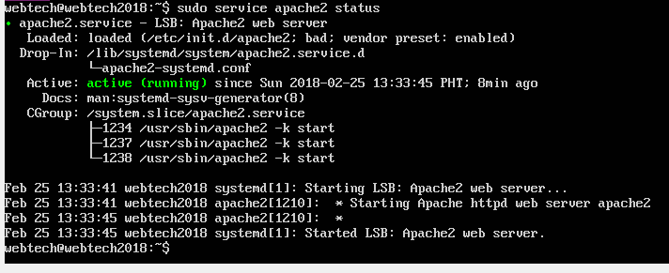The apache is running in default when the server started:

To manually stop the apache2, type:

To manually start the apache2, type:



To disable apache2 from running when the server started, type:

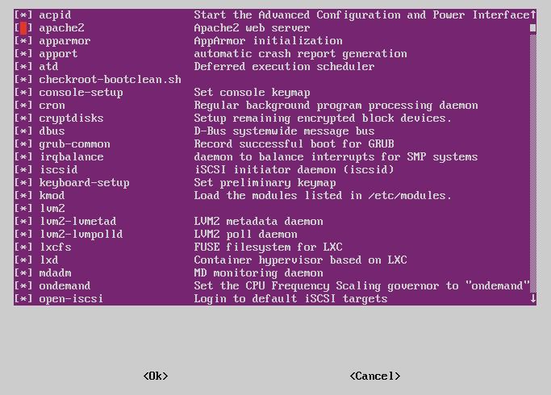then uncheck apache2 from the list

Then reboot the server to see changes